Henry Clay School Courier



**Important Upcoming Events**

**Friday, Nov. 4th: School Improvement Day--No School for Students!**

**Wed., Nov. 9th: Report Card Pick-Up 11:00-2:00 & 3:00-6:00**

**Thurs., Nov. 10th: Student Council Sponsored Food Drive Out-of-Uniform Day**

**Friday, Nov. 11th: Veteran’s Day--NO SCHOOL**

**Friday, Nov. 18th: 50 Cent Thanksgiving or Fall Colors Out-of-Uniform Day & 1st Quarter Honors Assembly Times K-4 @ 9:00 a.m. 5-8 @ 1:30 p.m.**

**Monday, Nov. 21st : November Assembly Performance By: 114, 209 and 210**

**Wednesday,**

**November 23rd,**

**Thursday,**

**November 24th &**

**Friday,**

**November 25th:**

**Thanksgiving Break**

**NO SCHOOL**

Volume 17, Issue 3

|  |
| --- |
|  |
| A Message From Principal Laurincik…  With the calendar turning to November, we can certainly feel its cold welcome with the weather. Please remember that the students need to have a coat, hat, and gloves on as they walk to school, as well as for recess. Please make sure that your child is dressed appropriately for the weather.  November is the month to be thankful…thankful for family, friends, a warm house, food on the table. As we take time this month to think about all we have, please remember those who are less fortunate. It is always a good idea to help those who are in need, so our Henry Clay School Student Council will be sponsoring a Food Drive Out-of-Uniform Day on Thursday, November 10th. On this day, for students to be out-of-uniform, we ask that you please bring in at least one nonperishable food item. The food collected will greatly benefit needy families in the Hegewisch Community.  November is a busy month for our students and staff. We have a couple of national holidays this month, starting with Veteran’s Day on Friday, November 11th. There will be no school on this day for students or staff members. Thanksgiving Break will take place on Wednesday November 23rd, Thursday, November 24th, and Friday, November 25th. There will be no school on these three days. Please have a lovely time with your family and friends.    The first nine weeks of the 2016-2017 school year have been very productive, and the 1st Quarter of the 2016-2017 school year will come to an end on Thursday, November 3rd. On Friday, November 4th, there is a School Improvement Day for our staff members; therefore, there is no school for students. Wednesday, November 9th, is Parent-Teacher Conferences/Report Card Pick-Up Day from 11:00-2:00 and 3:00-6:00. Please note that there is a 60 minute break from 2:00-3:00 so that our staff members can eat lunch. There will be no school for students on this day. Parents, it would be a good idea to make a specific appointment during the time allotment so that the teachers can see as many parents as possible on Report Card Pick-Up Day. Please do not forget that we have a Free Gradebook Parent Portal System that allows you to check your child’s grades any time of the day. You can also get alerted to your child’s grades, missing assignments, absences, etc. Please remember that during Report Card Pick-Up Day on Wednesday, November 9th, Ms. Milanovic will be in Room 305 to assist you in signing up for Parent Portal. Please make every effort to sign up for Parent Portal.  On Friday, November 18th, we will have our 1st Quarter Honors Assembly for Grades K-4 @ 9:00 a.m.; Grades 5-8 will take place at 1:30 p.m. We will honor our students with Perfect Attendance and our students who made the A Honor Roll or A/B Honor Roll. On Tuesday, November 22nd, we will have our monthly assembly featuring Rooms 114, 209, & 210. All are welcome! If you have any questions or concerns, please see me. |

Henry Clay School is still collecting **Campbell Soup Labels** and **Box Tops for Education**. We are able to redeem these items for gym and school equipment. All collected labels can be turned in to the **Main Office.**

**LSC**

The **November LSC Meeting** will take place on **Wednesday, November 16th at 1:00 p.m.** The meeting will take place in the Staff Lounge. All parents, teachers, and community members are welcome to attend.

**Campbell Soup Labels & Box Tops for Education**

**Jake** from **Sand Ridge Nature Center** will be visiting the **Pre-School** with a **special presentation** on **trees**.  He will visit the **A.M. class on Tuesday, November 1st** and the **P.M. class on Thursday, November 3rd.**

There is no school on Wed., Nov. 9th for report card pick-up. The preschool students do not receive report cards this quarter.

There are still a few spots available in preschool for students who turned 3 or 4 by September 1st.

**Pre-School News**

Don’t forget to check the **school’s** **website** [www.henryclayschool.com](http://www.henryclayschool.com) for important information and reminders. Also, please remember that each staff member has a **voice mailbox number** as well as an **e-mail address**, and a **classroom website**. Be sure to ask your child’s homeroom teacher for this important information so that you can communicate on a regular basis. The **staff’s e-mail addresses** and **website addresses** are listed under the **Faculty & Staff Page**.

**Tech News**

**LRE**

We have an extensive **LRE (Least Restrictive Environment) Library** in Room 211. If you need any information or help with anything pertaining to LRE, please stop by Room 211 to visit our library. You may even borrow a book or two—we have a two-week check-out period; just sign your name and write down the book you are taking on our check-out sheet, and the book is yours for two-full weeks! We can also offer help via conferencing; we are always available before school to answer any questions. Please stop by to see **Mrs. Mercon** in **Room 211**.

**Book Fee**

To help the school **defray the cost of workbooks and textbooks**, we are asking **each family** to **pay** a **BOOK FEE** this school year. A payment plan is available and all we ask for is a **$10 deposit per family**. Payments can be made throughout the school year. Please see Ms. Jackson or Mrs. Robinson in the Main Office if you have any questions or if you wish to make a payment. A detailed flyer of specific details is attached to this newsletter.

1 student: $25 2 students: $45 3 or more students: $65

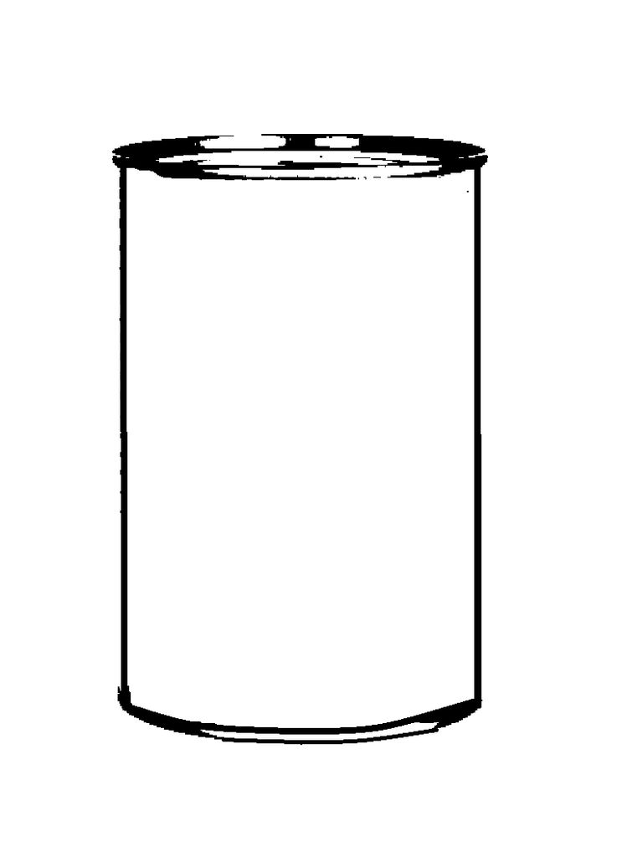

Food Drive Day

MCj02157780000[1]MCj03000730000[1]

Your Henry Clay Student Council is sponsoring a

**FOOD DRIVE DAY** on **Thursday, November 10, 2016**

Students, Teachers, and Staff are allowed to wear jeans

and be out of uniform on **11-10-16** if they bring in a

**NON-PERISHABLE FOOD ITEM**! Please dress in

**RED, White, and/or BLUE in honor of Veteran’s Day!**

**All of the non-perishable food items will be distributed**

**to needy families in the Hegewisch Community!**

If you do NOT want to wear jeans and be out of uniform,

you do not have to; however, you MUST then wear your

school uniform! If you are out of uniform and do not

bring in a non-perishable food item, you will receive a

detention and will not be able to participate in any of the

other Out-of-Uniform Days!

**News…From The Art Department**

As per the **students' required supply list**, **please bring in *one box* of pencils** to use during art class. These pencils will be for community use.

Common Sense & Internet Safety

**Internet Safety** and **Cyberbullying** are topics that need to be addressed regularly with our students every year, throughout the year. During technology class, our computer teacher, Ms. Milanovic, makes sure she addresses the issues about Internet Safety and Cyberbullying at least once per month during the students’ technology education classes. There are several **Family-Tip Sheets** online through a link on the **Henry Clay School** **Home Page** or the **Technology Page** to help your child and your family use technology responsibly. Please read over the tip sheets with your children at home so that they can continue to learn about the responsible use of technology while at home as well. In addition, a Digital Media Survey, Family Tip Sheets, and Activity Pages were also attached in a Parent Square Post a couple of weeks back. Please make sure to register for Parent Square to be able to access and/or download those valuable resources.



Please visit [www.commonsensemedia.org](http://www.commonsensemedia.org) for more information or visit our School’s website at [www.henryclayschool.com](http://www.henryclayschool.com) to use theCommon Sense Link on our Technology Page.

Please see the attached Media Agreement in this newsletter to make sure that you and your family are Good Digital Ciizens and that you are staying safe online.

