November 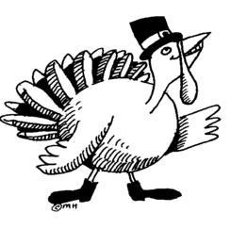 | 2016

SUN | MONDAY | TUESDAY | WEDNESDAY | THURSDAY | FRIDAY | SAT
 |  | 1 | 2 | 3  PAC Meeting 8:15 a.m.  BAC Meeting 9:15 a.m.  End of 1st Quarter | 4  School  Improvement Day  No School for Students! | 5
6  Daylight Saving Time Ends  Fall Back 1 Hour | 7  Scholastic  Book Fair | 8  Election Day  Scholastic  Book Fair | 9  Report Card Pick-Up  11:00-2:00 & 3:00-6:00  Scholastic Book Fair | 10  Student Council Sponsored Food Drive  Out-of-Uniform Day  Scholastic Book Fair | 11  Veteran’s Day  NO SCHOOL | 12
13 | 14  Scholastic  Book Fair | 15  Scholastic  Book Fair | 16  LSC Meeting  Staff Lounge @ 1:00 p.m.  3rd Grade Mighty Acorn Hegewisch March  Field Trip  Scholastic  Book Fair | 17  Scholastic  Book Fair | 18  50 Cent Thanksgiving  or Fall Colors  Out-of-Uniform Day  1st Quarter  Honors Assembly  K-4: 9:00 a.m.  5-8: 1:30 p.m.  Scholastic Book Fair | 19
20 | 21  November Assembly  Performances By:  114, 209 and 210 | 22  Kindergarten  Shedd Aquarium Field Trip  7th/8th  Field Museum  Field Trip | 23  Thanksgiving Break  NO SCHOOL | 24  Thanksgiving Break  NO SCHOOL | 25  Thanksgiving Break  NO SCHOOL | 26
27 | 28 | 29 | 30

